Make a Difference for Wild Orangutans

How to apply for RSPO membership
Use this link: http://www.rspo.org/members/apply

What is expected of members:
Here is an important link http://www.rspo.org/members/categories which outlines the expectations of RSPO members and code of conduct.
Which category and sector?
Which category of membership should our zoo or aquarium apply for? There are so many options…
Category: Ordinary Membership
Sector: Environmental and Conservation NGO
- Cheyenne Mountain Zoo chose to apply for Ordinary Membership, we wanted the ability to have voting rights on important issues. There is a big difference in membership fees between ordinary and affiliate memberships for some members.
- Ordinary Members are any organizations that have direct involvement in the palm oil supply chain, or associated NGOs (Non-governmental Organization). These members have voting rights at the General Assembly and are able to publicly state they are members of the RSPO.
- Generally not recommend: Affiliate Membership - these are individuals or organizations with an indirect involvement or interest in the palm oil supply chain, and do NOT have voting rights.

Possible discount for Environmental NGO’s
Example RSPO fee structure for NGO’s
During the application process a potential member should contact membership@rspo.org to ask about the discounted fee for non-profit organizations.

Decision and Discussion – should my zoo apply?
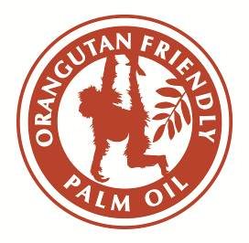
It may be helpful to familiarize conservation and/or education staff at your zoo with palm oil issues and the RSPO, and include interested staff members from those departments on your palm oil team. When considering whether or not to apply for membership, decision makers at your zoo may be interested to see a variety of Conservation NGOs who are RSPO members: http://www.rspo.org/members?keywords=&member_type=&member_category=Environmental+and+Conservation+NGOs&member_country=All

